First aid products expiration dates

When was the last time you checked the products in your first aid kit? Use our handy table below to check your products, write down the expiry dates and keep with your first aid kit as a reminder.
Product Name | Expiry Date
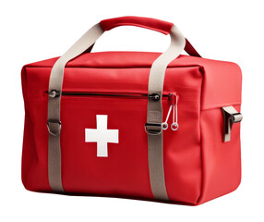
www.riskex.co.uk

